CaRe

Use-Case Specification

Version 2.0

Revision History

| **Date** | **Version** | **Description** | **Author** |
| --- | --- | --- | --- |
| 14/11/23 | 1.0 | <Initial version> | Triệu Nhật Minh |
| 26/11/23 | 2.0 | Revised version in PA3 | Triệu Nhật Minh |
|  |  |  |  |
|  |  |  |  |

Table of Contents

**1. Use-case Model 4**

**2. Use-case Specifications 4**

2.1 Use-case: [User + Shop] Sign up 4

2.2 Use-case: [User + Shop] Log in 5

2.3 Use-case: [User + Shop] Log out 5

2.4 Use-case: [User + Shop] Edit general information 6

2.5 Use-case: [User + Shop] Change password 6

2.6 Use-case: [User + Shop] Delete account 7

2.7 Use-case: [User] Search coffee shop 7

2.8 Use-case: [User] Filter coffee shop 7

2.9 Use-case: [User] View coffee shop’s information 8

2.10 Use-case: [User] Home page list suggest coffee shop 8

2.11 Use-case: [User] Add comment and rating 9

2.12 Use-case: [User] Report shop 9

2.13 Use-case: [Shop] Edit shop information 9

2.14 Use-case: [Shop] View list reviews 10

2.15 Use-case: [User] Booking 10

2.16 Use-case: [Shop] Manage booking 11

2.17 Use-case: [Shop] Dashboard 11

2.18 Use-case: [User] Favorite shops 11

2.19 Use-case: [User] Recently view shops 12

2.20 Use-case: [Admin] Administrator portal 12

# Use-case Model

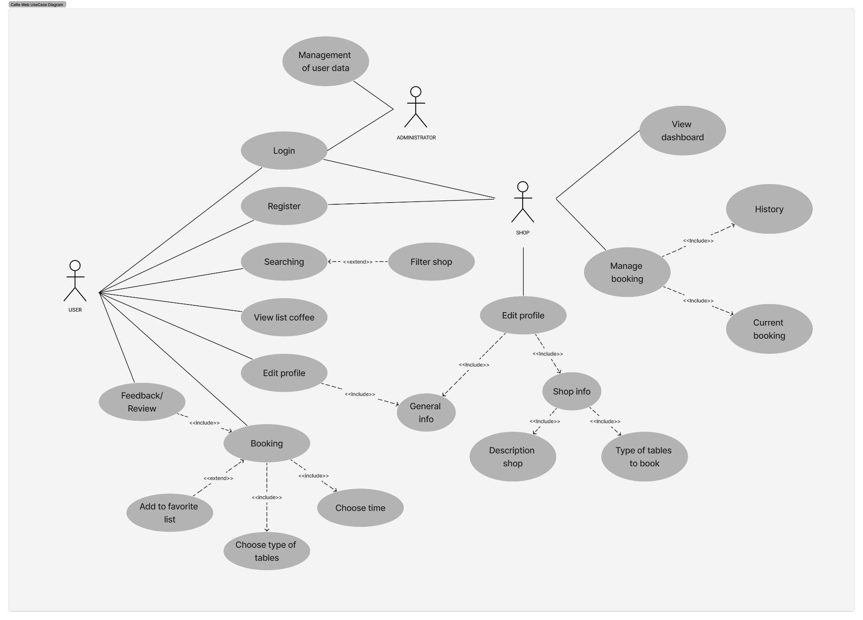

# Use-case Specifications

## Use-case: [User + Shop] Sign up

| Use case Name | [User + Shop] Sign up |
| --- | --- |
| Brief description | Users and shops can register in the system by choosing a role and providing their email, password, phone, address and other required information. The system will verify and grant access to the registered users and shops. |
| Actors | Customers (Users and shops) |
| Basic Flow | 1. Customers access the website through the search engine on the Internet or direct link. 2. From the homepage, if customers have not had an account, customers must sign up to view content on the website by clicking sign up. 3. Customers should provide all required information to sign up an account. |
| Alternative Flows | **Alternative flow 1: If customers do not have any account, they should create one to view content on the website**   1. Customers provide information to stepper form, including:  * Personal information (full name, email, phone number). * Password (password, confirming password). * Role (customers, shop management). * Customers go back to the sign in page to log in that new account.  1. After providing all necessary information, customers should submit the form to create an account.     **Alternative flow 2: If customers successfully create an account**   1. Users or shops will be navigated to the homepage. 2. If they want to login, they should press the login button.   **Alternative flow 3: If customers already have account**   1. There is a button to navigate to the login account for customers who already have an account. |
| Pre-conditions | Customers can only sign up by filling the sign up form on /SignUp route |
| Post-conditions | Users/ shops become customers and go to the homepage if successfully sign up otherwise stay in the Sign up page. |

## Use-case: [User + Shop] Log in

| Use case Name | [User + Shop] Log in |
| --- | --- |
| Brief description | The actors can access their accounts by entering their email and password on the login page. |
| Actors | Customers (Users and shops) |
| Basic Flow | 1. When customers access the application, customers must type their username and password to log in the application. 2. The system will check and if the account is valid, the system moves customers to the homepage of the application. |
| Alternative Flows | **Alternative flow 1: Customer has not created account yet.**   1. Customers must create a new account by clicking a link to move to the sign up page.     **Alternative flow 2: Customer types wrong username and password.**   1. Customer can not access to the application until he/ she types correctly   **Alternative flow 3: Customer logs in successfully**   1. Customer moves to the homepage of the application |
| Pre-conditions | Customers can only login by filling the login form on /SignIn route. |
| Post-conditions | User/ shop become active customers and go to the homepage if successfully log in otherwise stay on the Login page |

## 

## Use-case: [User + Shop] Log out

| Use case Name | [User + Shop] Log out |
| --- | --- |
| Brief description | The user confirms the logout and the system redirects the user to the login page. The alternative scenario is that the user cancels the logout and the system returns to the previous page. |
| Actors | Customers (Users and shops) |
| Basic Flow | 1. From any page, the actor hovers on the avatar on the navigation bar or clicks on it. 2. From the menu options, the actors choose the “Log out” item. 3. A prompt appears asking if the actor wants to sign out from the website, and the actor clicks “Yes”. 4. The system validates the actor’s sign out request and replaces the actor’s avatar button with a “Sign in” and “Sign up” buttons, then the use case ends. |
| Alternative Flows | There are no alternative flows for this use case |
| Pre-conditions | Actor has already signed in. He/ she can log out from any page in the CaRe website by choosing the log out option in the user profile dropdown from the avatar in the navigation bar. |
| Post-conditions | Actor successfully logs out from the website and is navigated back to the Log in/ Sign up page. |

## Use-case: [User + Shop] Edit general information

| Use case Name | [User + Shop] Edit general information |
| --- | --- |
| Brief description | This use case describes how users can modify their general data such as name, profile picture, etc. |
| Actors | Customers (Users and shops) |
| Basic Flow | 1. When actors click the edit button, they are allowed to change their information. They can edit their full name, phone number, city, and district that they are living in. 2. When actors click the confirmation button, the system will save new information, and show it to the profile page. Otherwise, when the actors click the cancel button, the system will re-display the old information. |
| Alternative Flows | None |
| Pre-conditions | Actors have already signed in. They can edit general information by clicking the edit button in their profile page and filling a form. |
| Post-conditions | New information such as name, phone number, city and district are updated. The email stays unchanged. |

## Use-case: [User + Shop] Change password

| Use case Name | [User + Shop] Change password |
| --- | --- |
| Brief description | This use case provides a field for users to change their password. |
| Actors | Customers (Users and shops) |
| Basic Flow | 1. Customers who want to change their password should input all the information in 3 fields given, namely “Old Password”, “New Password”, “Retype New Password”. 2. Once customers have completely confirmed the new password, they can hit the save button to save the new password. |
| Alternative Flows | **Alternative flow 1: Customer does not remember password**   1. From #1 of the basic flow, the customer cannot proceed with the basic flow, the customer needs to contact the administrator with their username and the reason for their request for further assistance and will have to wait until the administrator resets their password.   **Alternative flow 2: Customer types in the old password**   1. The customer follows the steps in #2 of the basic flow and receives a confirmation message, but the database does not reflect the customer’s input. |
| Pre-conditions | User/ shop has already signed in. They can edit the password by filling a form in their profile page. |
| Post-conditions | Password of the account must be updated if the customer’s new password and re-entered new password are the same. |

## Use-case: [User + Shop] Delete account

| Use case Name | [User + Shop] Delete account |
| --- | --- |
| Brief description | This use case gives customers a feature to delete their account in case they don’t want to be a member anymore. |
| Actors | Customers (Users and shops) |
| Basic Flow | 1. Customers must login and go to their profile page. 2. In case they want to delete their account, there is a function in their profile in order to help them. 3. When they press this button, a pop-up will be pushed up to re-confirm whether they want to delete their account or not. |
| Alternative Flows | None |
| Pre-conditions | Users/ shops have already signed in. They can delete their accounts by clicking on the delete account button in their profile page. |
| Post-conditions | An account is deleted. |

## Use-case: [User] Search coffee shop

| Use case Name | [User] Search coffee shop |
| --- | --- |
| Brief description | This use case provides users a feature to find the coffee shops based on the name of the shop. |
| Actors | Users |
| Basic Flow | 1. From any pages, the actor clicks on the search bar from the navigation bar. 2. Actor types name of the coffee shop wanting to search or any related features such as location. 3. The website returns a response page with the list of coffee shops that match the search. |
| Alternative Flows | None |
| Pre-conditions | Actor has already signed in. He can search from any page in the CaRe website by clicking on the search field on the navigation bar. |
| Post-conditions | Actor is navigated to the screen of coffee shops that meet the search criteria user entered is viewed |

## Use-case: [User] Filter coffee shop

| Use case Name | [User] Filter coffee shop |
| --- | --- |
| Brief description | This use case helps users easily find suitable coffee shops based on some specific conditions such as district and city. |
| Actors | Users |
| Basic Flow | 1. From a list of recommended tags, actors can select one to see a list of cafés that correspond with the chosen tag. 2. Actors can also filter and sort the results by distance, rating, price, and availability. |
| Alternative Flows | None |
| Pre-conditions | Actors have already signed in and searched. When the actors click the filter button after searching, the system will support users filter responses by tags, ratings or specific location (district, city). |
| Post-conditions | From the previous coffee shop list, the new list will be provided with only the shops that meet filter criteria such as ratings, location, etc. |

## Use-case: [User] View coffee shop’s information

| Use case Name | [User] View coffee shop’s information |
| --- | --- |
| Brief description | This use case specification describes how users can view all the information of a selected coffee shop, such as its description, open-time, phone, price range, and more. It also covers how users can see images of the shop environment and menu, to help them decide whether to visit or order from the shop. |
| Actors | Users |
| Basic Flow | 1. Users click on any shop card in the home page or in search result page. 2. Users are moved to the page of shop details. 3. System displays coffee shop details: Upon selection, the system displays detailed information about the coffee shop. This could include a description of the shop, its full address, photos, menu, and reviews from other users. 4. User takes further action: After reviewing the details, the user can choose to take further action. This could include getting directions to the coffee shop, saving it to their favorites, sharing it with friends, or even placing an order if the application supports it. |
| Alternative Flows | None |
| Pre-conditions | User has already signed in and clicked into the shop's card. System will direct the user to the shop's information page. |
| Post-conditions | * The users can see all of the shop's information: shop description, contact, images. * Users can view the menu. * Users can view all the ratings previous customers left. |

## Use-case: [User] Home page list suggest coffee shop

| Use case Name | [User] Home page list suggest coffee shop |
| --- | --- |
| Brief description | The use case specification describes how the user can view the list of coffee shops near their location and sort them by rating on the homepage of the app. |
| Actors | Users |
| Basic Flow | 1. User accesses home page: The user opens the web page and lands on the home page. 2. System displays recommendations: The system displays a list of recommended coffee shops on the home page. These recommendations could be based on the user’s past visits, preferences, or popular choices among other users. 3. User browses recommendations: The user browses through the list of recommended coffee shops. Each listing could include information such as the shop’s name, location, hours of operation, and customer ratings. 4. User selects a coffee shop: If a particular coffee shop catches the user’s interest, they can select it for more information. |
| Alternative Flows | **Alternative flow 1: Top rating**   1. The system could suggest coffee shops based on the users’ ratings. If the coffee shops receive high ratings, the system could prioritize similar coffee shops in the suggestions.   **Alternative flow 2: Location-based**   1. The system could suggest coffee shops based on the user’s current location. The closer a coffee shop is to the user’s location, the higher it would be on the suggestion list   **Alternative flow 3: Favorite shops**   1. The system could suggest coffee shops based on the coffee shops the user has marked as favorites. |
| Pre-conditions | When the user signed in successfully, the system will direct the user to the homepage. It contains top rated, nearest or user’s favorite coffee shops. It will also show the list of shops that the user has visited recently. |
| Post-conditions | At the home page, users can see the list of top rated coffee shops. |

## Use-case: [User] Add comment and rating

| Use case Name | [User] Add comment and rating |
| --- | --- |
| Brief description | Actors have already signed in and booked a table in one coffee shop so that they can add a comment and rating (one per order). |
| Actors | Users |
| Basic Flow | 1. Actors write some comments or post pictures related to feedback about shops in box below the information of coffee shop 2. The system saves the comments at the information in the coffee shop, so other actors can see those comments in the shop's page. |
| Alternative Flows | None |
| Pre-conditions | Actors have already signed in and booked a table in one coffee shop so that they can add a comment and rating (one per order). |
| Post-conditions | Actors can add comments of at most 150 words and set a rating for a shop. Actors’ comments and rating for a shop after 1 booking will be uploaded. |

## Use-case: [User] Report shop

| Use case Name | [User] Report shop |
| --- | --- |
| Brief description | Actors have already signed in and booked a table in one coffee shop so that they can add a comment and rating (one per order). |
| Actors | Users |
| Basic Flow | 1. The actor choose a shop card from home page or response search page or from another shop details page (the suggest list section) 2. Next to the name of the shop, the actor chooses a “Report” button. 3. A dialog opens, the actor enters the reason why he reports that shop (at left of shop’s name). 4. The actor clicks on the confirm button, a report is sent, or the actor clicks “Cancel”. 5. A dialog closes in both cases. |
| Alternative Flows | None |
| Pre-conditions | The actor has already signed in and booked a table in one coffee shop so that they have their rights to make a report of that shop. |
| Post-conditions | A reason which the actor adds is why he reports shops will be sent to the system. |

## Use-case: [Shop] Edit shop information

| Use case Name | [Shop] Edit shop information |
| --- | --- |
| Brief description | The use case is to manage the shop profile on the website. The shop owners can edit, update or delete their images and descriptions to showcase their products and services. This use case allows the shop owners to have control over their online presence and reputation. |
| Actors | Shops |
| Basic Flow | 1. When actors click the edit button, they are allowed to change their information. They can edit their contact information, description, images and menu. 2. When actors click the confirmation button, the system will save new information, and show it to the profile page. Otherwise, when the actors click the cancel button, the system will re-display the old information. |
| Alternative Flows | None |
| Pre-conditions | Actors have already signed in. They can edit their information by filling a form in the profile page. |
| Post-conditions | Actors can edit the contact information, descriptions, images and menu. New information must be updated. |

## Use-case: [Shop] View list reviews

| Use case Name | [Shop] View list reviews |
| --- | --- |
| Brief description | This use case allows shops to view the list of reviews that their customers give them. The shop can see the rating, comment, date and customer name for each review. The shop can also filter, sort and search the reviews by different criteria. The shop can use this information to improve their service and products. |
| Actors | Shops |
| Basic Flow | 1. Shops must login and go to their profile page. 2. There is an option in the menu bar to get access to the list of reviews. 3. When they press it, it will show all reviews have been made by users. |
| Alternative Flows | None |
| Pre-conditions | Shop has already signed in. They can view list reviews on the reviews page. |
| Post-conditions | The shop can view all the reviews (comment and rating) which their customers left to them after each booking. |

## Use-case: [User] Booking

| Use case Name | [User] Booking |
| --- | --- |
| Brief description | This use case outlines how a user can book a table at a restaurant, specifying details like date, time, table size and location, number of guests, and special requests. The system confirms the booking and sends a reminder to the user. |
| Actors | Users |
| Basic Flow | 1. Users choose time and type of table in the shop details page. 2. Users click on the booking button to confirm and send booking requests. |
| Alternative Flows | **Alternative flow 1: Users click on the booking button.**   1. The system move users to another page to review their information booking (time, type of page, address of shops)   **Alternative flow 2: Users send booking request**   1. After checking information and sending a booking request, if the request is sent, users are notified whether the sending is successful or failed. Users are moved back to the shop detail page if the request is sent successfully. |
| Pre-conditions | User has already signed in and went to the shop's information page. Users can book a table by choosing time and type of tables. |
| Post-conditions | Users successfully choose time and type of table. Their orders are successfully sent to the system, the system notifies them and the chosen coffee shop receives a new order. |

## Use-case: [Shop] Manage booking

| Use case Name | [Shop] Manage booking |
| --- | --- |
| Brief description | This use case describes how coffee shop owners can view and manage customer bookings through a system. They can accept or reject bookings, and the system updates the status and notifies the customer. The process ends when the owner logs out or returns to the main menu. |
| Actors | Shops |
| Basic Flow | 1. The actor enters his profile page at the avatar on the navigation bar. 2. The actor can see the table of all previous booking or current booking. Each row views the ID, name of the customers, time of that booking. 3. The actor clicks on the end of that row to confirm the booking or cancel that booking. |
| Alternative Flows | **Alternative flow 1: The actor view the booking details**   1. From the flow #2, the actor can click on the table row. 2. The website navigates the details page of that booking including which type of table that customer booked. |
| Pre-conditions | The actor has already signed in. The actor can manage booking in the manage booking page. |
| Post-conditions | * The actor successfully navigates to the Booking management screen and sees the list of all bookings, including previous, current bookings. * The actor successfully chooses whether to accept or cancel the booking. * The actor can view the details of any booking. |

## Use-case: [Shop] Dashboard

| Use case Name | [Shop] Dashboard |
| --- | --- |
| Brief description | This use case describes how a user can visualize booking and review metrics on a dashboard, filter data by various criteria, and export the data for further analysis. |
| Actors | Shops |
| Basic Flow | 1. The homepage of the dashboard displays an overview of the shop’s performance. This could include metrics like total sales, number of customers, popular items, etc. 2. The shop owner can view and manage their inventory. They can add new items (tables, photos, etc.), update existing ones, sales tracking, |
| Alternative Flows | None |
| Pre-conditions | When the user signed in successfully, the system will direct the user to the homepage. It contains top rated, nearest or user’s favorite coffee shops. It will also show the list of shops that the user has visited recently. |
| Post-conditions | At the home page, users can see the list of top rated coffee shops. |

## Use-case: [User] Favorite shops

| Use case Name | [User] Favorite shops |
| --- | --- |
| Brief description | This use case outlines how a user can view a list of liked shops on the app, accessed via the profile icon and "Liked Shops" option. It displays the shops' names, locations, and ratings, and allows further details to be viewed or shops to be unliked. |
| Actors | Users |
| Basic Flow | 1. Shops must login and go to their profile page. 2. There is an option in the menu bar to get access to the list of favorite shops. 3. When they press it, it will show all favorite shops that have been made by users. |
| Alternative Flows | None |
| Pre-conditions | User has already signed in and clicked the favorite button to add shops to their favorite list. |
| Post-conditions | * Users can add shops to their favorites list. * Users successfully navigate to profile/favorite shops and see all the shops they have added before. |

## Use-case: [User] Recently view shops

| Use case Name | [User] Recently view shops |
| --- | --- |
| Brief description | This use case outlines how the system shows the user the coffee shops they have recently viewed. Users can access this feature from the home page. |
| Actors | Users |
| Basic Flow | 1. Actors access home page: Actors open the web page and land on the home page. 2. System displays recently viewed shops: The system displays a list of viewed coffee shops on the home page. This list will be based on the user’s past visits to shops' detail pages. |
| Alternative Flows | None |
| Pre-conditions | Actors have already signed in and viewed some shops. So, when they visit the home page, they will see the recently viewed shops’ section. |
| Post-conditions | In the homepage, they can see a section with a list of coffee shops recently viewed. |

## Use-case: [Admin] Administrator portal

| Use case Name | [Admin] Administrator portal |
| --- | --- |
| Brief description | This use case outlines how the website offers a private page for the administrator to manage accounts, access the database via UI, and handle reports. The administrator can log in and perform tasks like account management, database access, and report generation. |
| Actors | Admin |
| Basic Flow | 1. As normal users, an administrator must log in his/her account to access the portal. |
| Alternative Flows | **Alternative flow 1: Administrator login successfully**   1. The system will move administrator to the admin portal page |
| Pre-conditions | Account for admin is predefined in the database. |
| Post-conditions | Admin can see all the list of accounts, bookings, etc.  Admin can edit or delete any accounts, bookings. |

## 